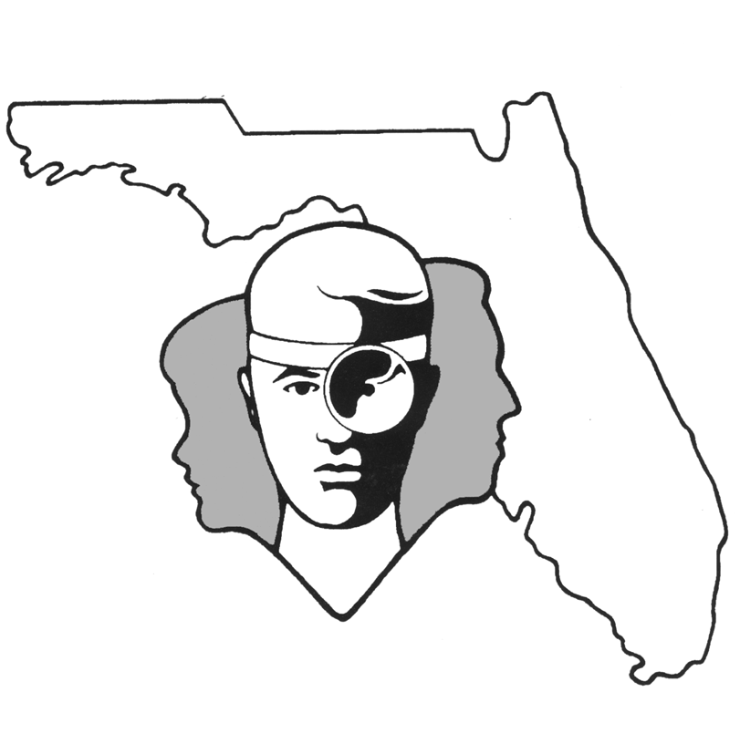
TALLAHASSEE EAR, NOSE & THROAT - HEAD & NECK SURGERY, P.A.

www.TallyENT.com Office Phone: 850-877-0101

PATIENT DISCHARGE INSTRUCTIONS: TYMPANOPLASTY, TYMPANOMASTOIDECTOMY or OSSICULOPLASTY
POST-ANESTHETIC CONSIDERATIONS: General anesthetics and other medications will be in your body 24 hours, so you may feel a little sleepy. This feeling will slowly wear off, but during this time adults should not:
- Drive a car, operate machinery or power tools  Take any medication except as directed
- Drink any alcoholic beverages  Make any important decisions – such as signing legal documents
Certain anesthetics and pain medications may produce nausea & vomiting which usually resolves by the evening of the surgery.

ACTIVITY: You should NOT engage in any strenuous activity (heavy exercise/straining /lifting heavy objects) for 3 weeks.
DIET: Progress slowly to a regular diet. There is no limitation in terms of what you eat as long as any nausea has subsided.

WOUND CARE: KEEP THE EAR DRY! This is very important until we are certain that the healing is complete. To wash your hair, you may use some "Dry Shampoo" available in the drug store, or lean your head backward over a sink the way it is done in a hair salon. Cotton coated in ointment can be placed in the ear canal to prevent water from entering the ear during the shampoo. DO NOT BLOW YOUR NOSE! If you feel like you are going to sneeze, try to do it with your mouth open.

MEDICATIONS: Use Tylenol, Motrin or the pain medication prescribed by your surgeon. Do not use any pain medication other than that prescribed by your surgeon. The prescribed medications may include an ear drop antibiotic and a pain medication. Take pain medications regularly. If you wait until the pain is very severe, the medications do not work as well. Almost all pain medications can occasionally cause nausea; if this is the case, something for the nausea itself may be required. The nausea and the pain medications can be taken together, and the pain medication often works better with this sort of combination, but you must be careful as the combination can be too sedating.
SYMPTOMS TO EXPECT: There may be a mild fever, but generally not above 101.5 degrees. A mild sore throat from being put to sleep usually resolves in 3-4 days. Ear pain may be moderate the first night but tends to improve quickly over the next several days. A mild to moderate amount of bloody discharge is common the first day or two and then tends to quickly decrease. If the patient has a procedure with only cotton placed in the ear, then the cotton may be changed as necessary. If you have a large "CUP" type dressing over the ear then the Velcro strap can be released and the gauze changed as needed. The gauze usually will not have much blood on it after the first two days. If you have one of the "CUP" type dressings, this can be removed after the first 24 hours. It then can be worn during the day in situations where the ear may accidentally get hit or at night so that you do not roll over on it while sleeping.
WHEN TO CALL YOUR PHYSICIAN:
- If you have a temperature over 101.5 degrees or have the chills
- Pain uncontrolled by the prescribed medication
- If there is a “drip-drip” type bleeding from the ear canal (this is unlikely to occur)
- If nausea becomes a problem

SPECIAL INSTRUCTIONS: A postoperative appointment has already been scheduled. Please refer to your Surgery Information Sheet or call the office to confirm the appointment date and time. We strongly suggest that a responsible adult be with the surgical patient the rest of the day and also during the night for the surgical patient's protection and safety. You should rest at home, but may be up and about according to doctor's instructions. Please contact your physician immediately if any emergent problems occur. If you find that you cannot contact them, but feel that your signs and symptoms warrant a physician's attention, go to the nearest emergency room. For non-emergent questions (i.e. appointments or general questions), please call during normal office hours.

